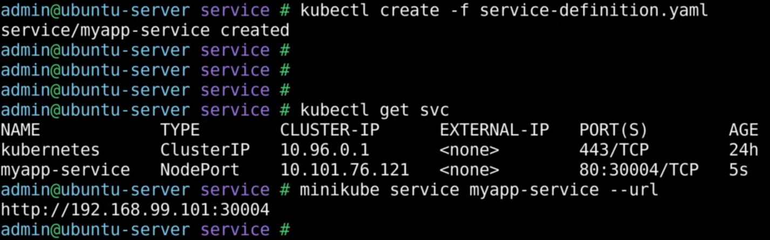

To get the URL using which you can access the application use the above command.